**Portfolio1 Part1 & Part2: Deploy a Sandboxed Network_v03**

|  |  |
| --- | --- |
| Cohort: | 2024.25 Cyber Security - LAC020L006S  Portfolio1 Phase2 |
| Name: |  |
| Date: |  |

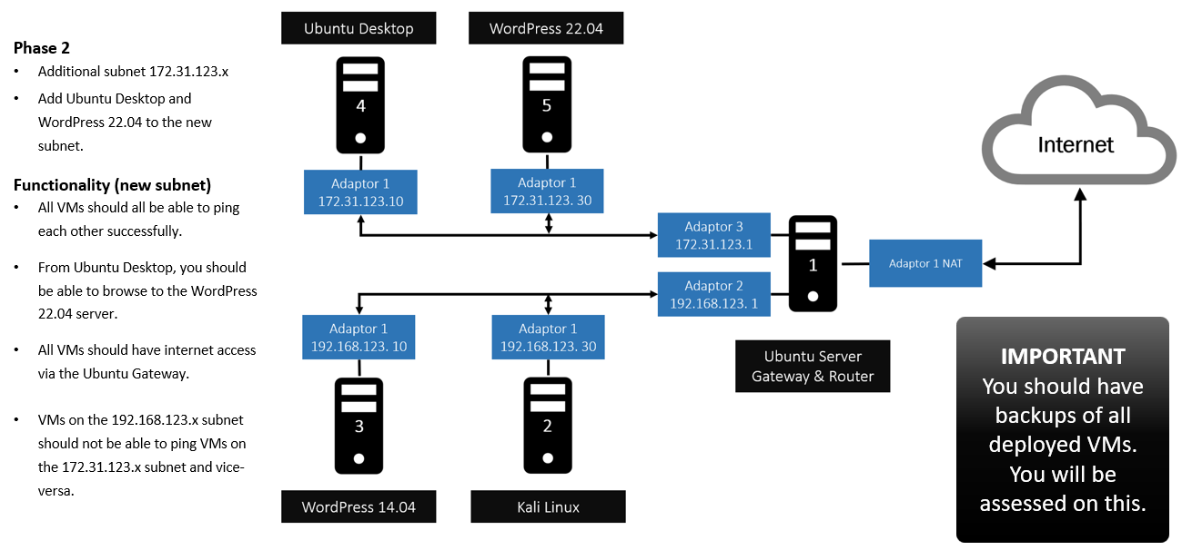

VM Setup Details

|  |  |  |  |  |
| --- | --- | --- | --- | --- |
| No | VM Name | OS/hostname | IP Address | Username/password |
| 1 | Ubuntu Gateway & Router | Ubuntu  *gateway* | enp0s3: 10.0.3.15/24 (NAT)  enp0s8: 192.168.123.1 (static)  enp0s9: 172.31.123.1/24 (static) | student/Student1 |
| 2 | Kali Linux | Debian/Kali  *kali* | eth0:192.168.123.10/24 (static) | kali/kali |
| 3 | WordPress1 | Ubuntu 14.04  *wordpress1* | eth0:192.168.123.20/24 (static) | student/Student1 |
| 4 | Ubuntu-Desktop | Ubuntu 22.04  *desktop* | enps03:172.31.123.10/24 (static) | student/Student1 |
| 5 | WordPress2 | Ubuntu 22.04  *Wordpress2* | enps03:172.31.123.30/24 (static) | student/Student1 |

|  |  |  |  |  |  |
| --- | --- | --- | --- | --- | --- |
| No | VM Name | vCPU | vMemory | vNIC Adapter | subnet |
| 1 | Ubuntu Gateway & Router | 2 | 2048MB | 3 | 1: subnet1 (192.168.123.0)  2: NAT  3: subnet2 (172.31.123.0) |
| 2 | Kali Linux | 2 | 2048MB | 1 | 1 |
| 3 | WordPress1 | 2 | 2048MB | 1 | 1 |
| 4 | Ubuntu-Desktop | 2 | 2048MB | 1 | 1 |
| 5 | WordPress2 | 2 | 2048MB | 1 | 1 |

**Network Settings:**

|  |  |  |
| --- | --- | --- |
| No | VM Name | Network Settings |
| 1 | Ubuntu Gateway & Router | sudo nano /etc/netplan/00-installer-config.yaml  save the changes and run  sudo netplan apply    ip address show |
| 2 | Kali Linux | sudo nano /etc/network/interfaces    ip address show    sudo ifdown eth0  sudo ifup eth0  sudo nano /etc/resolv.conf ; change the nameserver to 8.8.8.8  ping -c3 192.168.123.1  ping -c3 192.168.123.20  ping -c3 8.8.8.8  ping -c3 [www.google.com](http://www.google.com) |
| 3 | WordPress1 | sudo nano /etc/network/interfaces    ip address show    sudo ifdown eth0  sudo ifup eth0  sudo nano /etc/resolv.conf ; change the nameserver to 8.8.8.8  ping -c3 192.168.123.1  ping -c3 192.168.123.30  ping -c3 8.8.8.8  ping -c3 www.google.com |
| 4 | Ubuntu_Desktop | sudo nano /etc/netplan/01-network-manager-all.yaml  save the changes and run  sudo netplan apply    sudo nano /etc/resolv.conf ; change the nameserver to 8.8.8.8  ping -c3 172.31.123.1  ping -c3 172.31.123.30  ping -c3 8.8.8.8  ping -c3 www.google.com |
| 5 | WordPress2 | sudo nano /etc/netplan/00-installer-config.yaml  save the changes and run  sudo netplan apply    sudo nano /etc/resolv.conf ; change the nameserver to 8.8.8.8  ping -c3 172.31.123.1  ping -c3 172.31.123.10  ping -c3 8.8.8.8  ping -c3 www.google.com |

Screenshots:

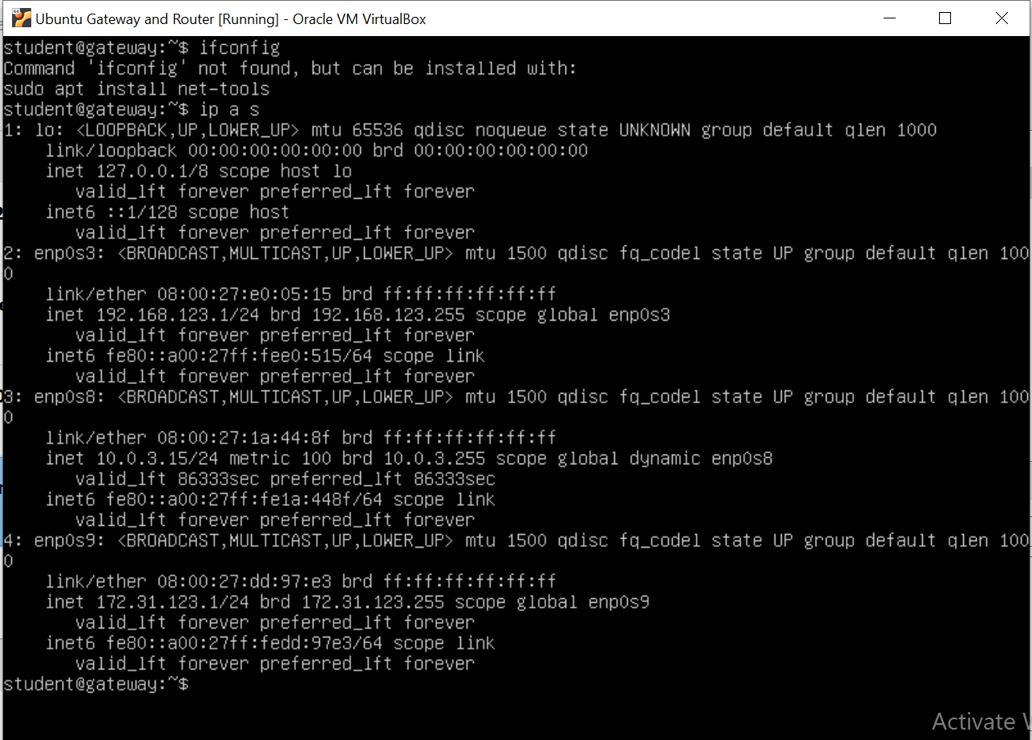

**From Ubuntu Desktop**

|  |  |
| --- | --- |
| No | Description |
| 1 | IP configuration: ***ip address show / ifconfig*** |
| 2 | Ping to WordPress 22.04: ***ping -c3 172.31.123.30*** |
| 3 | Ping to Ubuntu Server 22.04 (Gateway) ): ***ping -c3 172.31.123.1*** |
| 4 | Ping to Ubuntu Server 14.04 (Gateway) ): ***ping -c3 192.168.123.10*** |
| 5 | Ping to google DNS 8.8.8.8 |
| 6 | Ping to google [www.google.com](http://www.google.com) (to test DNS) |
| 6 | Browse to the WordPress 22.04 server |

**From Ubuntu Server 22.04 (WordPress) VM**

|  |  |
| --- | --- |
| No | Description |
| 1 | IP configuration: |
| 2 | Ping to Ubuntu Desktop (172.31.123.10) |
| 3 | Ping to WordPress Server 22.04 (Gateway): ping -c3 172.31.123.30 |
| 4 | Ping to google DNS 8.8.8.8 |
| 5 | Ping to google [www.google.com](http://www.google.com) (to test DNS) |

**From Ubuntu Server 22.04 (Gateway) VM**

|  |  |
| --- | --- |
| No | Description |
| 1 | IP configuration: |
| 2 | Ping to Ubuntu Desktop VM |
| 3 | Ping to Ubuntu Server 22.04 (WordPress) |
| 4 | Ping to google DNS 8.8.8.8 |
| 5 | Ping to google [www.google.com](http://www.google.com) (to test DNS) |

**Export & Backup Evidence**

|  |  |
| --- | --- |
| No | Description |
| 1 | Export & Backup your VMs files to a USB drive or personal One Drive storage  Screenshot of your backup: |